

CA 3 Research Report

Viktoriia Bielhrad
studID
Valentina Pruteanu
studID
Rysean Dyle Soy
studID
Angelo Bundac
studID
Department of Informatics School of Informatics and Cybersecurity
TU Dublin Blanchardstown Campus
Dublin 15.

Word Limit for Assignment: 3000-5000 Actual Word Count: 4737

Course: COMPH1037
Module: Operating Systems
27/04/2025
Contents
Performance & Memory Management 3
Introduction 3
Preloading & Prediction Process (msedge.exe --type=renderer) 3
Virtual Memory & Paging (pagefile.sys in Windows Task Manager) 3
Task Scheduler & Background Updates (msedgeupdate.exe) 6
Conclusion 8
References 8
Process management 9
1.Main Edge Process(msedge.exe) 9
Test 9
How to test this: 9
2. Renderer Process 11
3. GPU Process (msedge.exe --type=gpu-process) 11
Test 11
YouTube Video Playback (--type=gpu-process) 11
Observation: 12
Inactive tabs 13
CONCLUSION 13
Network Process 14
Network Process 14
Test 14
How to do it? 14
Monitor DNS Queries (using Wireshark): 14
Monitor YouTube streaming 4k and 144p network usage 14
Monitoring Network Usage/ bandwidth with 10+ tabs 14
Conclusion 15
Crash Handler (msedge.exe --type=crashpad-handler) 15
Testing 15
How to do it? 15
Conclusion 15
SmartScreen & Tracking Protection (smartscreen.exe) 15
What is SmartScreen? 15
Test 16
How to do it? 16
Conclusion 16
Reference 16
Sandbox Process 16
What does a sandbox do? 16
How to install Windows Sandbox 17
Third-Party Process 18
What is a third-party in Microsoft Edge? 18
Blocking Extensions in Microsoft Edge Using Intune in Microsoft Edge while reducing CPU and memory usage. 19
Recommendations: 19
Extension Process 20
What does extension do in Microsoft Edge? 20
How to add an Extensions to Microsoft Edge 20
How Extensions Impact CPU and Memory Usage in Microsoft Edge? 21
Best Practices to Reduce Memory and CPU Usage 22
Conclusion 22
References 22

Viktoriia Bielhrad, 1093 words

Performance & Memory Management

Introduction
In my research, I will examine how Microsoft Edge manages memory and performance, including its use of RAM, the role of preloading and prediction processes, the functions of virtual memory (pagefile) and committed memory, and how background updates are handled through Task Scheduler.

Preloading & Prediction Process (msedge.exe --type=renderer)

Microsoft Edge uses cookies to remember our preferences, site language, site settings, login details and to preload pages that we frequently visit or may visit in order to speed up the browsing process in the browser.
Usually, cookies are enabled by default. There is also a corresponding button in the settings to allow preloading of pages.


Settings > Cookies and site permissions > Cookies and site data:
- Allow sites to save and read cookie data.
- Preload pages for faster browsing and searching.

To take a look at Microsoft Edge's memory usage, we can open Task Manager. For example, on my laptop, the browser is currently using 24.5MB of memory for "Utility: Network Service" and 3.4MB for "Spare Renderer" processes, which are closely related to how cookies are used and managed.

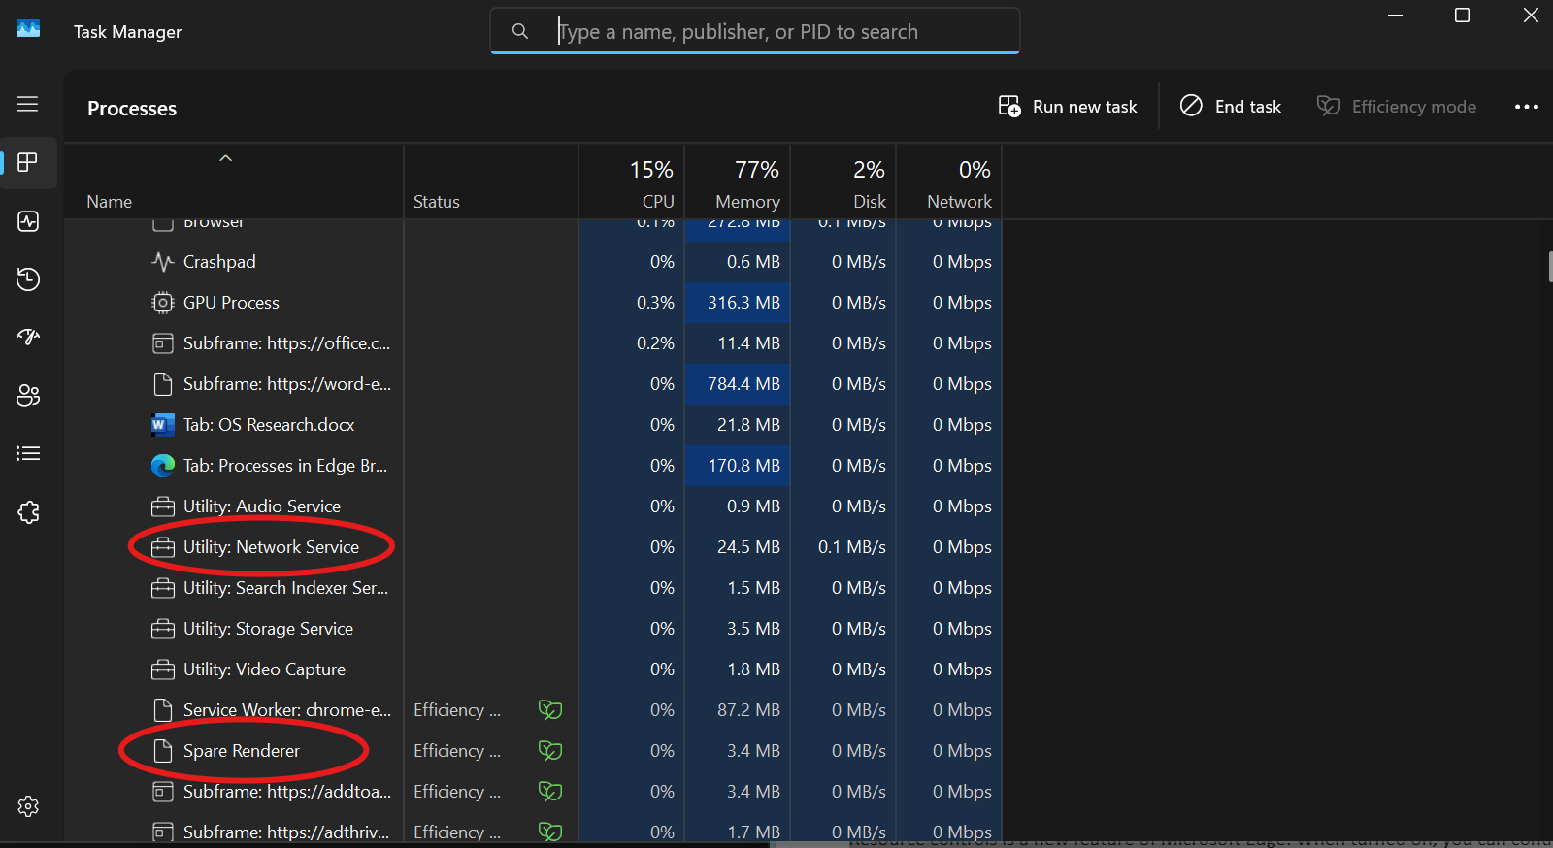

If we want to reduce RAM usage by setting a limit for it, for background activity such as preloading sites or other processes, we can use a feature in Microsoft Edge called Resource Controls.

Virtual Memory & Paging (pagefile.sys in Windows Task Manager)

What is pagefile?

A Pagefile is a file with the extension .sys stored on the computer's system drive. It reduces the RAM load, allowing the computer to work without interruptions.

Automatic Pagefile management is enabled in Windows by default.

Pagefile size is larger than physical memory:
- Minimum - 1.5 times;
- Maximum - 4 times.

How paiging works?

Paging is the process of moving inactive processes from physical memory (RAM) to the Pagefile when RAM runs out of space. This is needed in order to free up memory for active applications. Рagefile essentially works as secondary storage, so it is also considered virtual memory.

During Paging, the РС stores and uses data retrieved from secondary memory in main memory. The operating system receives this data in equal-sized blocks called pages.
When the program tries to access data/code that is not currently available in the physical memory - the page fault occurs.

Paging is a modern solution to the problem of physical memory capacity, which allows to increase the computer's capabilities for efficient task performance. Thanks to it, we can enjoy uninterrupted computer operation even if we run out of RAM.

Committed Memory

Commit charge is the amount of memory that Windows reserves in case it needs it. The amount of memory depends on the page size. When Edge starts, it requests the committed memory space, and Windows offers it through the page size or virtual memory. This process is dynamic, so not all memory will necessarily be filled.

The amount of RAM used by Edge depends on the number of tabs, advertisements, web browser extensions, content, screen resolution, window size, and the number of browser windows opened.

Committed memory shows how much memory is in use, both physical RAM and Pagefile. The following image shows amount of Committed memory before I start opening applications that require a lot of memory.

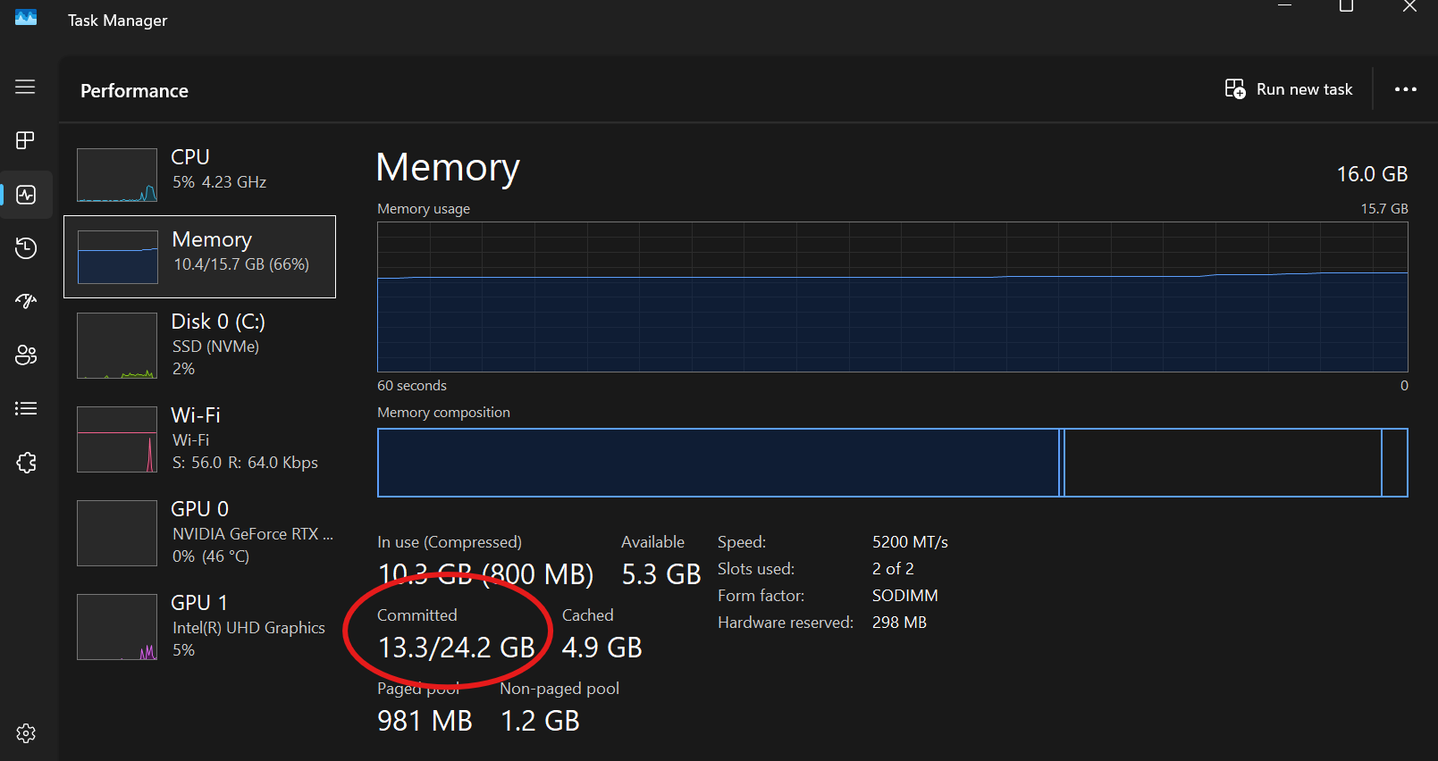

And this is after I loaded the memory. If the amount of memory exceeds 24.2GB, the Pagefile will be used, because it works as an extension of physical memory.

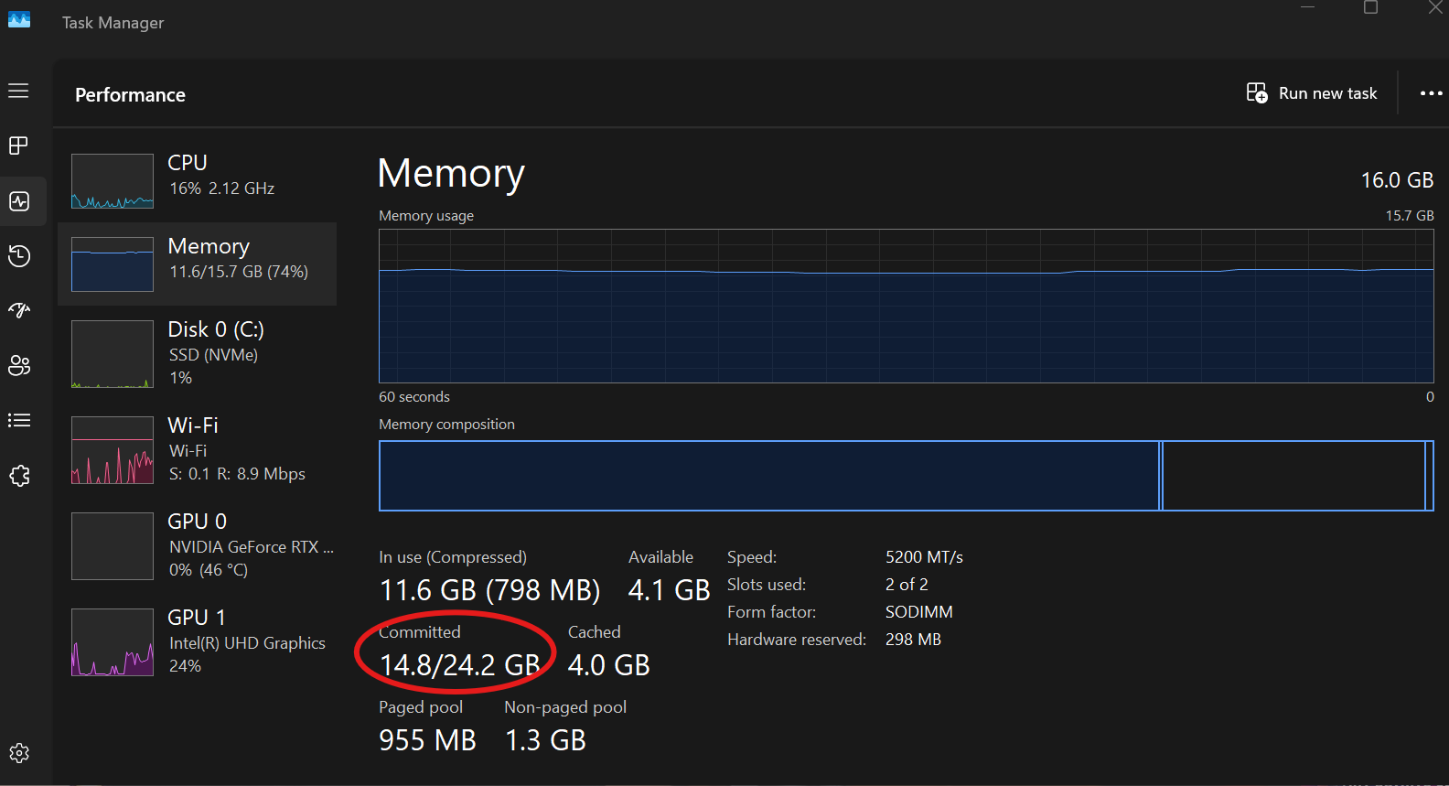

These are the current settings for the Pagefile (Virtual Memory) on my laptop (Windows 11). We can see that the system manages it automatically. Its size is also visible.

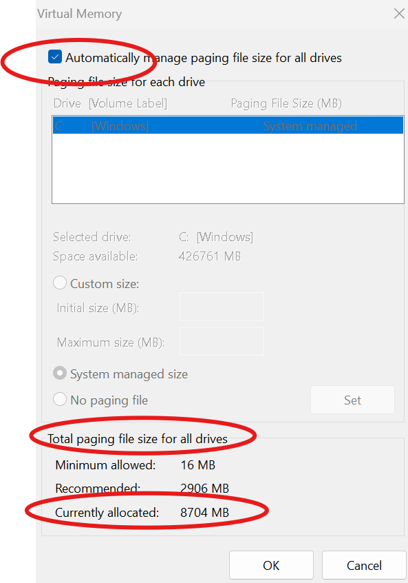

Virtual memory
Virtual memory allows programs to use more memory than physically exists by mapping the virtual addresses used by the programs to physical addresses. This translation is performed by the memory management unit (MMU) in the processor.

Windows dynamically manages this address space, allocating and reclaiming space as needed.

Advantages of Using Pagefile or Virtual Memory

- No Program Crashes – always a spare place to store data for inactive applications;

- Memory Dumps – store memory dumps that can be used for troubleshooting.

Disadvantages of Using the Virtual Memory as a Substitute for RAM

- Sub-par Performance – it will take longer to load a program from virtual memory than from RAM;

- HDD Impact – Heavy load on the hard drive where the Pagefile is located. The hard drive must constantly move data from RAM to the disk, which affects its durability.

Task Scheduler & Background Updates (msedgeupdate.exe)

What is MicrosoftEdgeUpdate.exe process?

The MicrosoftEdgeUpdate.exe file is regularly used by the Microsoft Edge browser.

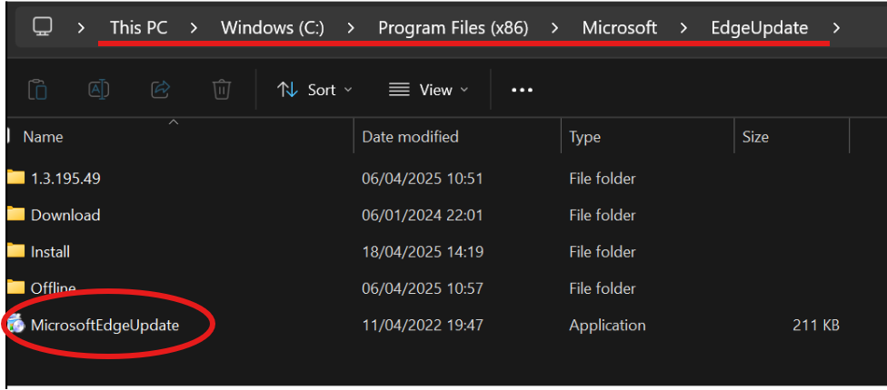

When connected to the Internet, it searches for new versions and updates and automatically downloads them.
We can see it in the Task Manager when it checks for updates.

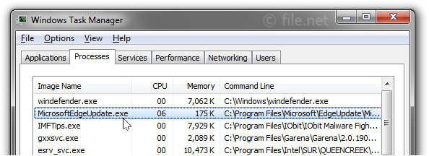

It is important to update Microsoft Edge regularly for smooth operation and security.
Usually, it uses minimal CPU and memory when not actively downloading updates. However, you can remove it if it is really consuming a lot of CPU or if it is malware disguised under the same name.

Task Scheduler

The Windows Task Scheduler is a tool that the OS uses to automatically start programs and services.

How Task Scheduler Manages Microsoft Edge

- Edge Auto-Update (msedgeupdate.exe) - Task Scheduler runs msedgeupdate.exe, which:

- Checks for new versions of Edge;

- Downloads and installs updates in the background;

- Keeps the browser secure and up-to-date.

- MicrosoftEdgeUpdateTaskMachineCore and UA - After installing Edge, the system creates two scheduled tasks:

- MicrosoftEdgeUpdateTaskMachineUA (runs every day or at login)

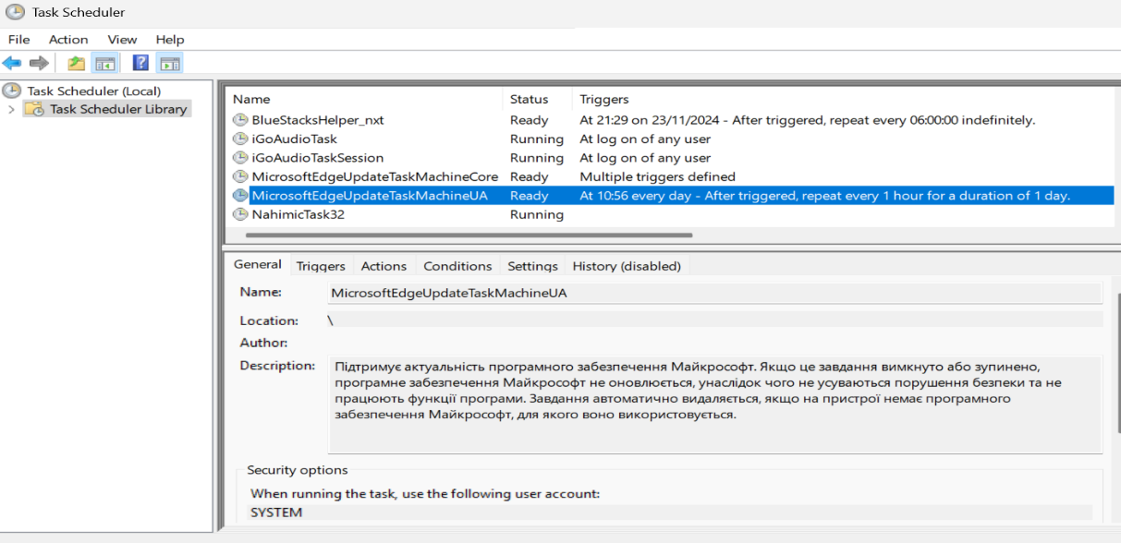

- UA -> Update Application

- Runs: MicrosoftEdgeUpdate.exe /ua/installsource scheduler, that runs every hour
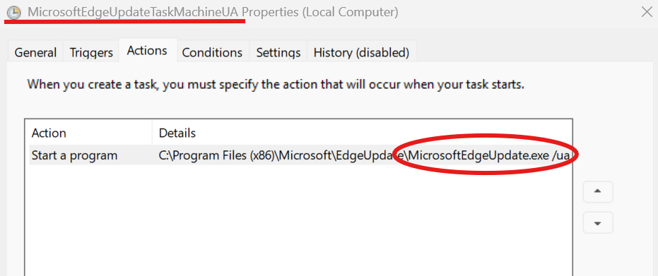

- Updates: Edge Update, Edge Stable, Beta, Dev, Canary, and Edge WebView2 Runtime

- MicrosoftEdgeUpdateTaskMachineCore (runs every time the user logs in and once a day)
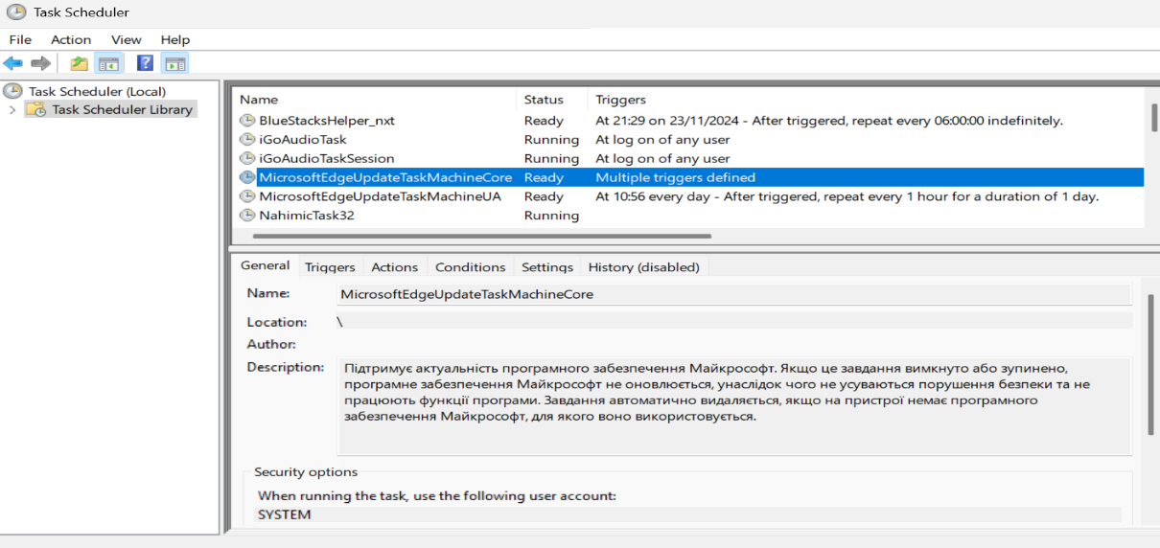

- Runs: MicrosoftEdgeUpdate.exe /c.
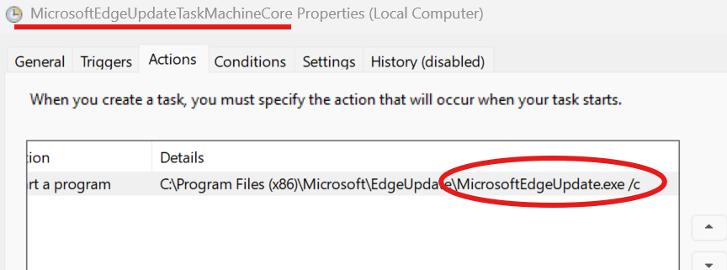

- It can also update Edge and WebView2, but UA usually handles this, so it is not commonly used.

- Background services
- In addition to updating, Task Scheduler can run tasks such as Preload Edge (for faster startup) and run background synchronization of user data (bookmarks, passwords, etc.). These tasks keep Microsoft Edge up-to-date, efficient, and ready to run quickly (without user intervention).
- Task Scheduler does not control Edge's behavior when browsing the web.

Conclusion
Microsoft Edge's performance is the result of intelligent resource allocation across multiple background and active processes. The browser uses both physical and virtual memory (Pagefile) to perform tasks smoothly, even under high load. Features like Task Scheduler keep the browser up-to-date and responsive without user intervention. Virtual memory provides flexibility and prevents system crashes. Overall, Edge's approach to memory and performance management is efficient and adaptive, designed to ensure stability, security, and speed.

References
Enable or disable preload pages for faster browsing and searching in Microsoft Edge. (2025, April 6). Windows 11 Forum. https://www.elevenforum.com/t/enable-or-disable-preload-pages-for-faster-browsing-and-searching-in-microsoft-edge.34959/

Manage cookies in Microsoft Edge: View, allow, block, delete and use - Microsoft Support. (n.d.). https://support.microsoft.com/en-us/windows/manage-cookies-in-microsoft-edge-view-allow-block-delete-and-use-168dab11-0753-043d-7c16-ede5947fc64d#bkmk_usecookiestopreload

AnandK@TWC & AnandK@TWC. (2025, April 5). Microsoft Edge High memory usage in Windows 11. The Windows Club. https://www.thewindowsclub.com/microsoft-edge-high-memory-usage

Community, T. H. (2018, April 20). How to manage virtual memory (Pagefile) in Windows 10. Tom’s Hardware. https://www.tomshardware.com/news/how-to-manage-virtual-memory-pagefile-windows-10,36929.html

Brink. (2017, February 6). Manage virtual memory pagefile in Windows 10. Ten Forums. https://www.tenforums.com/tutorials/77692-manage-virtual-memory-pagefile-windows-10-a.html

Sahay, M. (n.d.). What is Pagefile & Virtual Memory in Windows? PCInsider. https://www.thepcinsider.com/what-is-windows-page-file-virtual-memory/

Vg. (2020, April 29). How to disable or remove MicrosoftEdgeUpdate.exe process running in Task Manager? AskVG. https://www.askvg.com/how-to-disable-or-remove-microsoftedgeupdate-exe-process-running-in-task-manager/

What is MicrosoftEdgeUpdate.exe? (n.d.). https://www.file.net/process/microsoftedgeupdate.exe.html
Mona. (2023, April 10). Creating a scheduled task in Windows 11.
Technipages. https://www.technipages.com/scheduled-task-windows/

Valentina Pruteanu (1027 words)

Process management
Microsoft Edge is a browser that interacts with a large part of the operating system functions and is .It is a multi-process browser, which allows the entire browser to run in a single operating system process and can also create separate processes for different components of the browser.

1.Main Edge Process(msedge.exe)
The main Browser process is the main brain that checks and makes sure everything is working properly, ensuring the correct functionality of the menu, settings and addresses. This is the key point where the user interacts with the browser directly. I will use tools such as Windows Task Manager, Edge Task Manager, Process Explorer, and Resource Monitor to observe and capture data.

Test

How to test this:
1.
We will open only one tab in Microsoft edge on only one tab being the homepage and see how it affects the CPU usage on the computer that is visible in the task manager. We can see that having a tab open on Microsoft edge increases the CPU usage by 0.5% and we can also see that the memory increases by 495 megabytes.
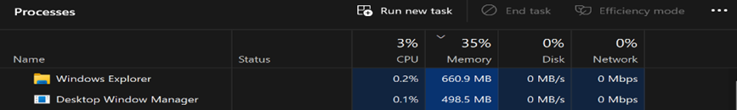
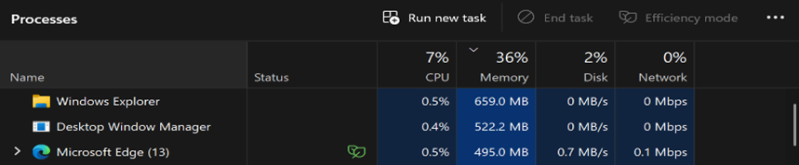

2.

Opening Multiple Tabs(YouTube, Gmail, TuDublin, Amazon, Booking), we will observe Memory usage increased significantly from 150-400 MB per tab, depending the content. We notice that the YouTube site uses more memory compared to Gmail, TuDublin, Amazon and Booking. Because YouTube is a site that mostly has high-quality video and audio content and requires more memory for buffering and rendering, and also has the interface for recommendations, ads, comments that rely on scripts and consume more memory.
We also see that the number of threads has increased, and this can also take up CPU usage depending on what. The amount on CPU usage may vary depending if they are a lightweight thread or a heavy thread.

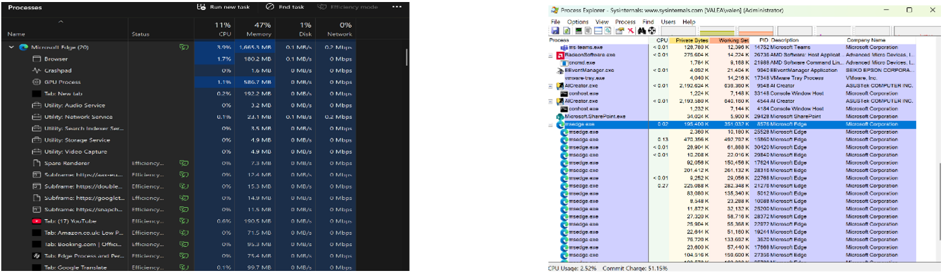

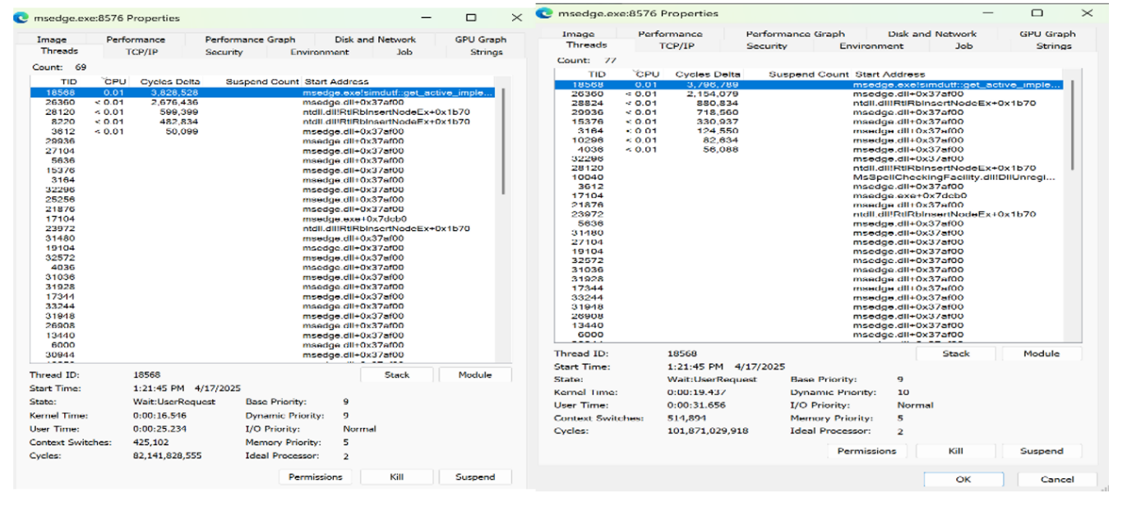

CPU usage spiked during page loads.
In the screenshot above we can see the presence of a large number of context switches even when the CPU is used less, this happens because applications that are GUI-based have multiple threads waiting for input, network responses which cause frequent context switches.

3.
When accessed, the browser loads many files into memory and this can cause page faults as the system fetches the necessary data from virtual memory

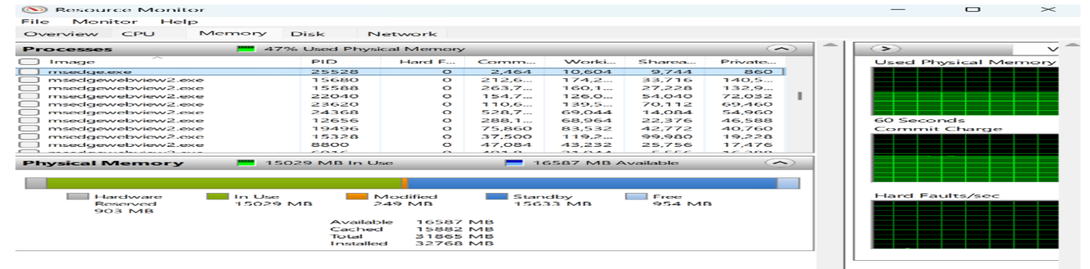
Here we can see that hard page fault is 0 because in a high-performance system with sufficient RAM it is minimal as seen in the screenshot.
2,464 KB -how much virtual memory is reserved for the process.

2. Renderer Process
The rendering process handles everything in a browser tab. It uses the main thread to handle most of the code, while worker threads handle specific tasks like JavaScript. The compositing and raster threads also help ensure that the web page runs smoothly.
Every webpage is made of a code and everything we interact with is part of a code to make the webpage functional for the user. The main codes that webpages use is HTML, CSS, and JavaScript.
We can check the code of any page we visit on Microsoft Edge by pressing “Ctrl+Shift+I” and on the side the code to the page is shown as in the screenshot .Here we can see how a simple homepage on Microsoft Edge is made up of multiple code that ends up becoming an interactive page for the user.

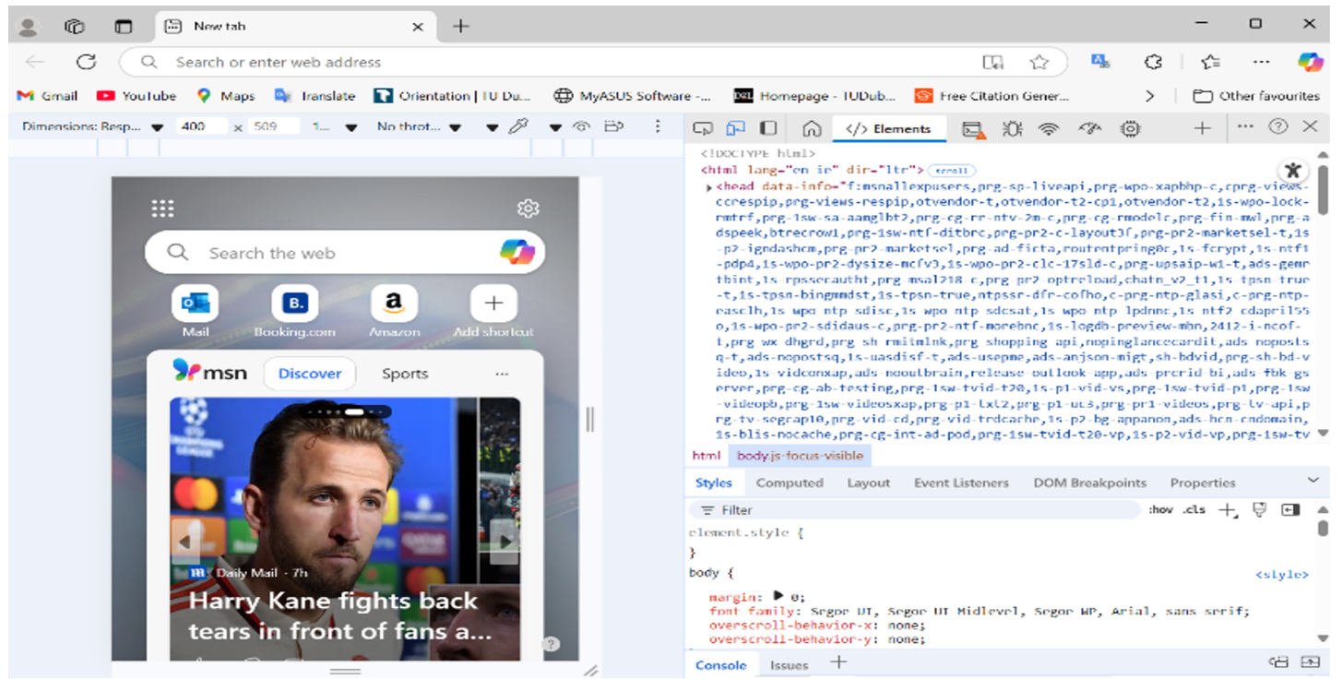

3. GPU Process (msedge.exe --type=gpu-process)
GPU rendering uses a graphics chip for rendering instead of a processor, which is why the rendering process is very fast. They are specifically designed for fast image rendering. GPUs have come to the rescue to offload the workload from the processor and not hamper the computing performance. GPU rendering executes a single set of instructions and allows the processor to focus on other sequential processing tasks.

Test

YouTube Video Playback (--type=gpu-process)
If we access a video on YouTube, we can see that in the GPU tab of Task Manager, GPU usage increased and 3D rendering is well but CPU usage remained low. These results are shown from a 1080p video as the quality on which a video runs may have a big effect on the GPU usage.
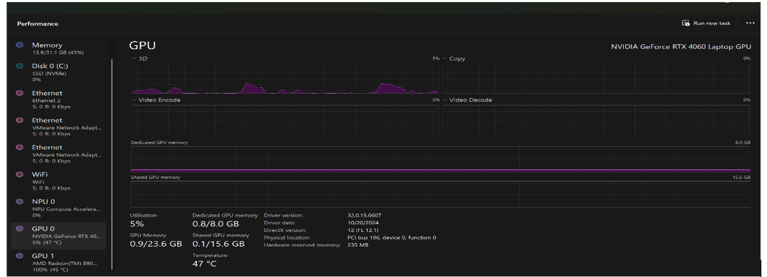
Here we can see the big difference on what the quality of a video playing can have, an 8K video which is a 4380p resolution video that has a lot more GPU usage in compariso to the 1080p video.
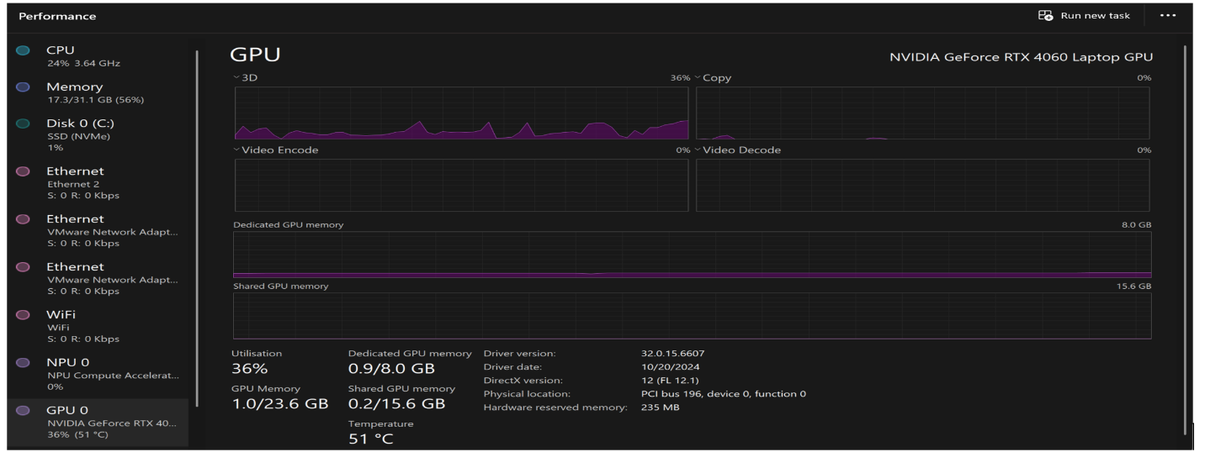
Here we used the Proces Explorer tools and we can see the difference in GPU usage from an 8K video and a 1080p video. We can clearly see a 4.35% difference in GPU usage between the higher quality video and a 1080p video. We can also see a big difference in the GPU memory usage between the two videos playing.
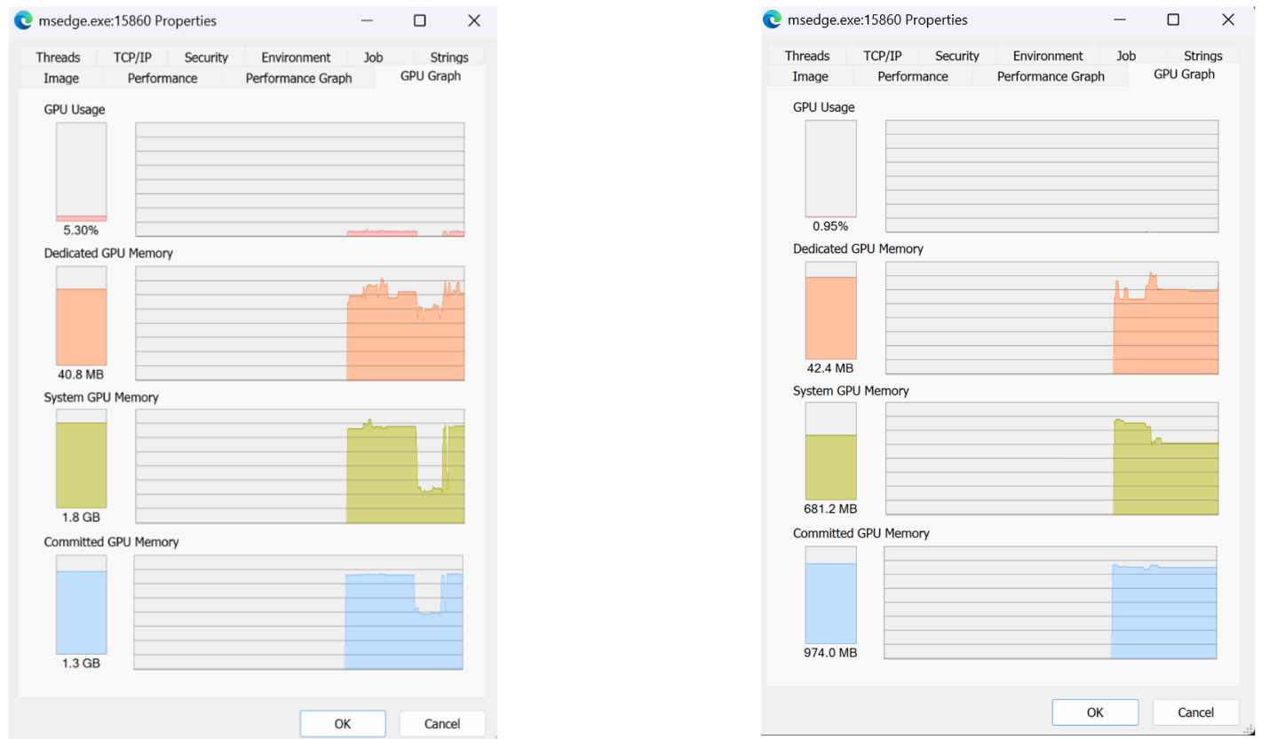

Observation:
. GPU memory usage increased
. CPU thread usage has been reduced and there is more workload is on the GPU.
. The video played smoothly at 1080p, indicating an efficient download.
. The video at 8K also played smoothly but had a memory usage.

Inactive tabs
If we lewave tabs inactive for a few minutes we see that they are put to sleep by the browser in order to keep CPU usage at a low. Below we can see how multiple inactive tabs in Microsoft Edge has a very low or no CPU usage.
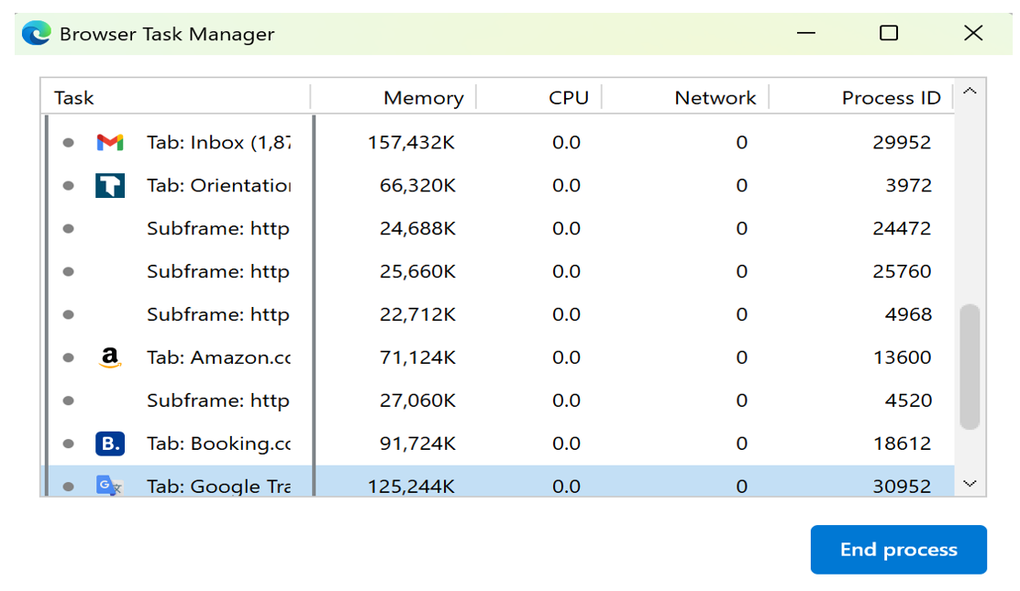
. Inactive tabs use fewer to no CPU resources leaving energy for active tasks.
. Threads stayed inactive and weren't doing anything.
. Inactive tabs used less memory.

CONCLUSION
In conclusion for these three processes we see how the memory is used up by different processes from Microsoft Edge such as: the Main Proces, the Rendering Proces and the GPU processes. We can observer how the CPU handles different tasks and the strain that these tasks have on the CPU. We also observer how the GPU is used to render different video qualities and how it helps take some strain off the CPU. There are different types of processes and how they impact the system of a computer such as threads, context switches and page faults. We clearly see how each of these processes heavily interacts with the system resources and how they impact our computer.

References
https://blogs.windows.com/msedgedev/2020/09/30/microsoft-edge-multi-process-architecture/

Microsoft Edge using a lot of GPU - Microsoft Community

blogs.windows.com

Rysean Dyle Soy (1,034 words)

Network Process

Network Process
The Network Process inside Microsoft Edge manages all types of online communication that run through the browser. The main functions of the Network Process include website connection setup and domain name resolution alongside data download and encryption tasks.

Test

How to do it?
- Download Wireshark
- Now open Browser and open YouTube.
- Open Wireshark and filter DNS
- Find YouTube DNS and record it.
- Now we test network usage based on resolution.
- Play video in 4k and record usage from task manager and resource manager.
- Repeat same step but with 144p resolution this time.

Monitor DNS Queries (using Wireshark):

YouTube
After opening the YouTube website through Edge browser Wireshark detects a DNS request being sent from local machine (192.168.228.226) to DNS server (192.168.228.109). Domain name resolution services of the Network process transform www.youtube.com into its associated IP address.

Monitor YouTube streaming 4k and 144p network usage

We going to test the bandwidth when streaming 144p. During test the bandwidth for 144p seemly low in Task manager Network is 0-0.1Mbps and for resource monitor we are getting 26,000 total B/s.

During 4k streaming we significant increase on Network usage in Resouces Monitor we are getting 1,974,970 b/sec total, in task manager we are getting 29.6 Mbps.

Resource Monitor
Resolution | Send b/sec | Receive b/sec | Total b/sec
144p | 0 | 26,000 | 26,000
4K | 0 | 1,974,970 | 1,974,970

Task Manager
Resolution | Network Usage
144p | 0.1 Mbps
4K | 29.6 Mbps

Monitoring Network Usage/ bandwidth with 10+ tabs

On Microsoft edge we open 1 tab network usage is low around 0.1 Mbps in task manager, for Resource Monitor is 150 b/sec total. When we open 10 tabs of YouTube it increases to 818,390 b/sec in Resource Monitor, in task manager I'm getting around 3.9-14 Mbps
Tabs | Resource Monitor network Activity | Task Manager Network Usage
1Tab | 150 b/sec total | 0.1 Mbps
10 Tabs | 818,390 b/sec | 3.9-14Mbps

Conclusion
We can see that having high resolution on streaming and more workload (multiple tabs) in browser have higher network usage and we see some slow loading and lags. While having 1 tabs or lower resolution like 144p on streaming does not require a lot of usage and it run smoother but for streaming quality is not idle for watching video.

Crash Handler (msedge.exe --type=crashpad-handler)

Testing
To test this, we going to simple method to crash browser by using this address “edge://inducebrowsercrashforrealz” it will force website to crash, The testing protocol starts by using single-tab crashes to set a reference point which advances to multi-tab tests (5+ tabs) to evaluate operational scalability and compare the CPU usage and recovery time.

How to do it?
- Open browser open 1 tab for first test
- Type this edge://inducebrowsercrashforrealz address
- Open browser again and restore monitor the CPU usage in task manager and monitor time recovery with stopwatch/timer app
- Do repeat method above but with 5 tabs this time

Tabs | CPU usage | Recover time | Successful
1 Tab | 42% | 5.01 sec | Yes
5 Tabs | 74% | 17.13sec | Yes

Conclusion
The Microsoft Edge crash handler restores individual tabs within about 5 seconds with its CPU usage reaching maximum at 42%. efficiency decreases proportionally to the number of tabs the system requires to restore. The table shows an established link between browser activity levels and how much longer recovery times become and how high CPU resource usage grows.

SmartScreen & Tracking Protection (smartscreen.exe)

What is SmartScreen?

Microsoft Edge comes with the built-in security feature SmartScreen to protect users while they browse the internet.it has 3 main features.

- Alerting you to suspicious web pages: As you browse the web, SmartScreen check website pages and see if they are suspicious. If it finds a suspicious site, SmartScreen displays a warning page advising and block page and you to continue with caution and giving you an opportunity to provide feedback to Microsoft. (Microsoft)

- Defending against phishing and malicious sites: To protect against phishing and malicious websites, SmartScreen compares the sites you visit to a constantly updated list of known phishing and malware sites. If it detects a match, SmartScreen will display a warning indicating that the site has been blocked for your safety. (Microsoft)

- Screening downloads: SmartScreen scans your downloads to compare them against a list of reported malicious software sites and programs that are known to be unsafe. If it finds a match, SmartScreen will warn you that the download has been blocked for your safety. Additionally, SmartScreen checks your downloaded files against a list of popular and well-known downloads by Microsoft Edge users and alerts you if your download is not included on this list. (Microsoft)

Test
In this test we going monitor the CPU usage/spike, Performance Impact (devs tools) and We going use demo malicious URL from Microsoft defender. Compare the 2 URL activity.
For this test we will use process explorer for CPU usage and Thread and for performance impact we will use inspect element in edge and select performance tab.

How to do it?
- Download all necessary tools process explorer (for devs tool it built in Microsoft edge)
- Open Microsoft edge open 1 tab on google search
- Open process explorer and find smartscreen.exe and check property select thread
- Open devs tools in Microsoft edge check performance
- Record all activity
- Repeat all step with demo link from defender SmartScreen

URL | CPU Usage | thread | Performance Impact
Malicious | 0.01 % | 5 | 88.9 ms
Clean, (Google) | 0% | 3 | 396 ms

Conclusion
During test we found out that SmartScreen of Microsoft edge does not consume a lot of CPU usage it runs every efficient on blocking and stopping any malicious URL and downloads. There 2 threads increase from clean URL like google and their CPU usage stay 0 %. and we check we monitored the performance impact using devs tools / inspect element in Microsoft edge we see that delay on page where SmartScreen showed 89 ms this due there only few things in block page which only have text and background color , while google page take 396 ms it has thing need load image, Nav bar, search bar and more. In conclusion smartscreen.exe is efficient does not require a lot of CPU usage.

Reference
support.microsoft.com. (n.d.). How can SmartScreen help protect me in Microsoft Edge? - Microsoft Support: https://support.microsoft.com/en-us/microsoft-edge/how-can-smartscreen-help-protect-me-in-microsoft-edge-1c9a874a-6826-be5e-45b1-67fa445a74c8.
‌

Angelo Bundac, 1,011 words

Sandbox Process

What does a sandbox do?

An isolated virtual machine is called a sandbox environment. A built-in security feature of Windows Sandbox enables users to use apps in a secure, private environment. It is a cybersecurity method intended to defend the system from ransomware and malware. IT workers who need to test or execute untrusted software without harming their primary system may find this very helpful.

The only versions of Windows that support Sandbox are Pro, Enterprise, and Server. Your version of Windows might not support it if it isn't installed.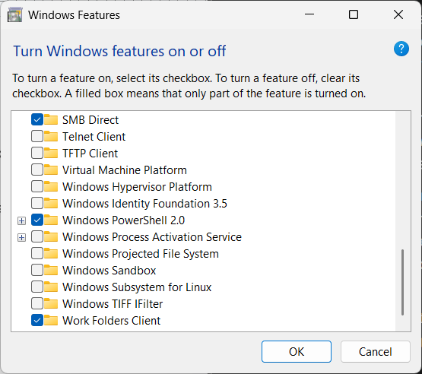

How to install Windows Sandbox

- From the taskbar, type Turn on Windows Features on or off to bring up the Features tool in the search box.
- Select Windows Sandbox and then OK. Restart the computer.

There are three versions of the Windows Sandbox: Pro, Enterprise, and Education. Windows Home is typically installed on laptops, although not all functions are available. testing new software, including those from untrusted sources in Windows Sandbox without harming any systems.

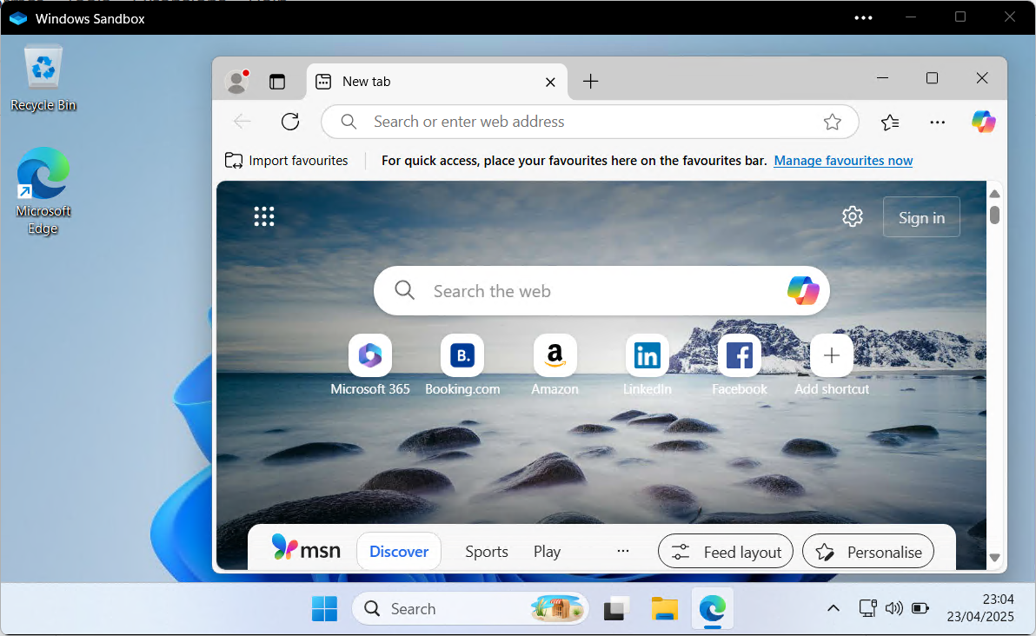

This is a temporary version of the Windows sandbox. Everything you installed or saved will be lost when you close it. It starts like new each time you open it. Applications installed on your primary computer cannot be used in the sandbox unless they are reinstalled.

System Prerequisites

Processor | ARM64 (for Windows 11, version 22H2 and later)
Memory | 4GB (8GB Recommended)
Storage | 1GB - (SSD Recommended for the better performance)
CPU Cores | 2 CPU Cores (4 cores with hyper-threading
Virtualization | Must be enabled in BIOS

The following licenses are available for Windows Sandbox:

Windows Edition and Licensing Requirements

Windows Pro | Windows Enterprise | Windows Pro Education/SE | Windows Education
Yes | Yes | Yes | Yes
The CPU and Memory usage difference between the real system and Windows sandbox for Microsoft Edge.
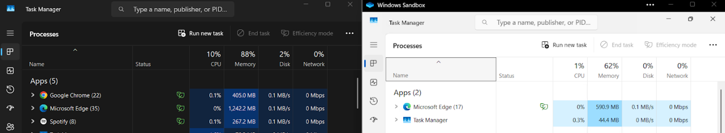
In Task Manager, you can see the difference between the real Windows system and Windows sandbox using CPU and Memory while using Microsoft Edge most of the time.

Windows (Left)
CPU | 10%
Memory | 1,242.2 MB (1.2GB)

Windows Sandbox (Right)
CPU | 1%
Memory | 592.9MB

Third-Party Process

What is a third-party in Microsoft Edge?

In Microsoft Edge, a third party is any external organization, program, or piece of data that is not under the direct control of either the user or Microsoft, the company that makes the browser.

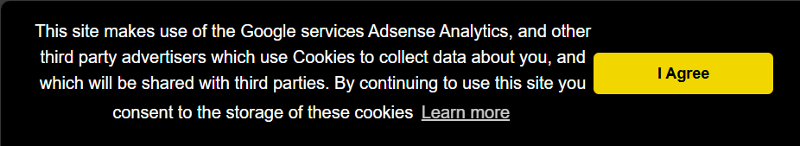

Blocking Extensions in Microsoft Edge Using Intune in Microsoft Edge while reducing CPU and memory usage.

The company can set rules to restrict which browser extensions can be installed if it uses Microsoft Intune to manage its devices. This allows the management of numerous computers at once.

- Sign in by visiting the Microsoft Endpoint Manager Admin Centre.

- On Devices > Configuration profiles >, click Make a profile

- Select:
- Operating system: Windows 10 and above
- Profile type: catalogue of settings

- Look for "Extensions" under Microsoft Edge in the settings:
- Under "Allow specific extensions to be installed (User)," enter the IDs of the extensions you want to allow exclusively.
- Under "Control which extensions cannot be installed (User)," place a star * to prevent all extensions.

- Select the devices or users to apply this to, then assign the profile.

Recommendations:
How to block third-party cookies in Microsoft Edge
- Choose Settings by clicking the three dots icon in the top-right corner, then Privacy, Search, and Services.

- Choose Third-party to block all third-party cookies.

Extension Process

What does extension do in Microsoft Edge?

Microsoft Edge extensions, often known as add-ons, are little tools that we can install to enhance the browser's features or do more. They let you customise Edge to your own requirements and tastes, add new features, and change how the browser functions.

How to add an Extensions to Microsoft Edge
- Click on Extensions by the address bar in Microsoft Edge.
- There, you can control your extensions.
- Note: Select Extensions by clicking on Settings and more (the three dots) if you don't see it.
- Click "Get Microsoft Edge extensions."
- After selecting your favourite one, click Get.
- When a permission request appears, review it and click Add extension if you're good with it.
- You will receive an alert stating that the extension has been added.

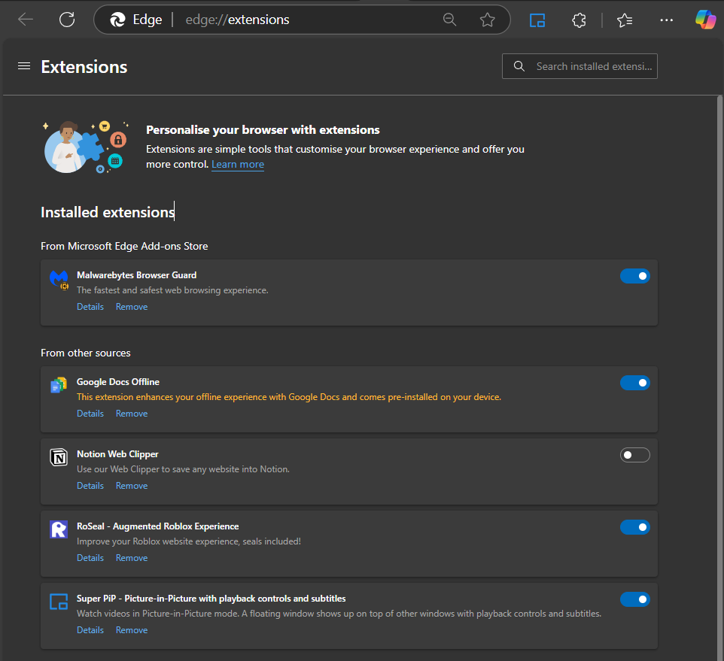

Microsoft Edge extensions provide functionality to the browser for a variety of reasons. Here is an example of what extensions can do?
- Ad Blockers
- Password Managers
- Discount codes

How Extensions Impact CPU and Memory Usage in Microsoft Edge?
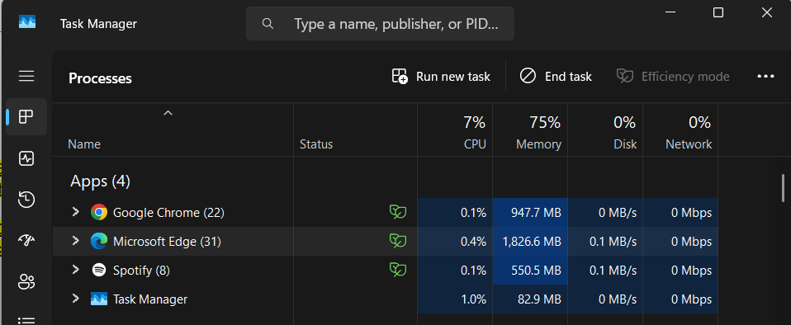Microsoft Edge shows overall memory and CPU usage, even though only a few extensions that It still has enabled most of the time. This browser with extensions on has been used extensively for a long time, as some unused extensions are still on but have not yet been uninstalled.

CPU | 7%
Memory | 1,826.6 MB (1.8GB)

Extensions in Edge do use RAM and CPU. The more extensions we have enabled, the higher the overall memory and CPU usage of the browser.

Best Practices to Reduce Memory and CPU Usage

- Close tabs and windows immediately
- Remove or disable unused extensions
- Use tabs and efficiency mode to optimize performance
- Regularly clear cache and cookies if resource usage remains high.

Conclusion

You can securely test programs with Windows Sandbox without causing any damage to your primary PC. It is limited to certain Windows versions, such as Pro and Enterprise. It always begins anew since everything within is gone when you close it.

It improves system performance by using less CPU and memory than your primary system.

An excessive number of extensions, or add-ons, might cause Microsoft Edge to lag. Intune can be used by companies to either permit or prohibit specific ones.

To maintain the functionality of your PC and browser:
- Close any tabs you are not using. Disable or remove any unnecessary extensions.
- Use Edge's power-saving features; frequently clear your cache and cookies.

By taking these small steps, you can keep your system secure and quick.

References

https://techcommunity.microsoft.com/discussions/windows10space/what-is-the-windows-sandbox/4248508

https://www.hornetsecurity.com/en/blog/sandbox-environment/

Windows Sandbox | Microsoft Learn

Install Windows Sandbox | Microsoft Learn

https://support.microsoft.com/en-us/microsoft-edge/add-turn-off-or-remove-extensions-in-microsoft-edge-9c0ec68c-2fbc-2f2c-9ff0-bdc76f46b026

https://www.kaspersky.com/blog/how-to-block-cookies-in-chrome-safari-firefox-edge/43505/

https://www.ctm360.com/blogs/cyber-advisory-securing-browser-extensions

TU DUBLIN, BLANCHARDSTOWN CAMPUS
DEPARTMENT OF INFORMATICS
LECTURER STEPHEN WHITE

DECLARATION ON PLAGIARISM
I declare that the work I/We am(are) submitting for assessment by the examiner(s) is entirely my(our) own work, except where the author or source has been duly referenced and attributed.
I confirm that this material has not been previously submitted for a degree or any other qualification at TUD or any other institution. I further confirm that I have read and understood the Institute policy on plagiarism in assignments and examinations (3AS08.doc) and that I am not, so far as I am aware, in breach of any of these regulations.

Signed : _Viktoriia Bielhrad, Valentina Pruteanu,Rysean Dyle Soy, Angelo Bundac
Date : __________27/04/2025_________________

